Core Ab (Ab Isolator)
- 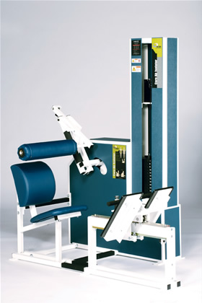Strong abdominal muscles provide a solid foundation for spinal support.
- The Ab Isolator isolates the abdominal muscles by neutralizing the hip flexor muscles.
- The Ab Isolator also restricts the arching in the base of the spine to prevent low back discomfort.
EXERCISE - Select a resistance with which you can perform 8 to 12 complete repetitions. Sit in seat with hips as far back as possible. Push position handle down to spread thighs as wide as possible. Arch your back and pull movement arm pad down against your chest. Place upper arms on top of pad. Avoid using hands or arms to assist in exercise. Rotate your chest downwards toward your thighs. Movement from start to full flexion should take at least 4 seconds. Pause for 1 second and return to the starting position using a count of at least 4 seconds. Do not pause, immediately begin the next repetition. All movement should be controlled and deliberate. Avoid throwing or jerking the weight. Continue the exercise until you are unable to complete a repetition in good form.
COMMENTS - For best results, exercise should be performed throughout the greatest range of pain free movement. Vary the starting position by removing the selector pin from the weight stack moving the movement arm to the desired stating position and inserting the selector pin at the desired level of resistance.

