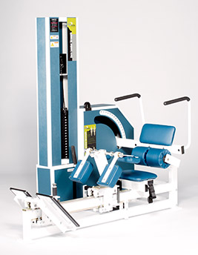Core Strength (Lumbar Strength)
- Patented, effective pelvic restraint system that keeps gluteus and hamstring muscles from interfering with the targeted exercise area.
- Provides isolation of the lumbar spine muscles, increases stability and allows specific, intensive strengthening.
INSTRUCTIONS -
- Select a resistance permitting complete and proper repetitions for a duration of 90 - 180 seconds.
- Set resistance to appropriate weight.
- Sit in machine, pressing firmly against pelvic pad. Raise knee restraint and bring it forward. Place both feet on foot platform and position platform so knees are slightly higher than your hips. Fasten seat belt.
- Tighten knee restraint so it presses evenly on the top of your thighs and shins.
- Grab the left arm handle and with your right hand pull the release lever towards you to disengage the weight stack.
- Lean forward as far as you comfortably can. Push lever arm forward to engage the weight stack.
- 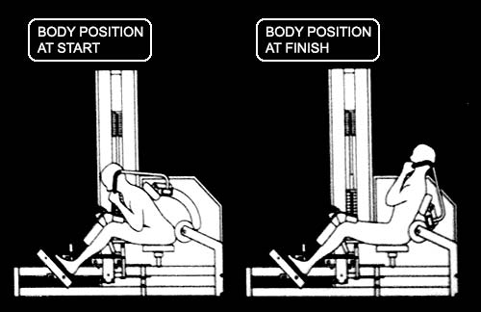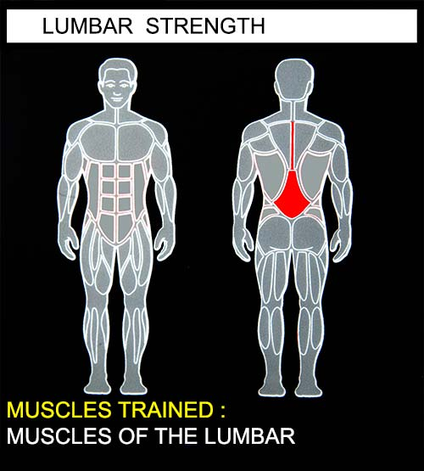Press slowly and smoothly backwards, go as far as you can or until the machine stops you. Pause. Return slowly and smoothly to the forward position. Repeat.
- When finished with your set, lean forward and release the weight stack. Lean back to return to idle position and press lever forward to engage.

