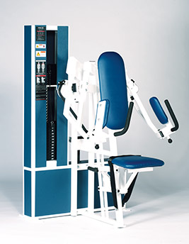Lateral Raise
Movement arm handles adjust for varying amounts of external rotation.
Movement axes positioned to reduce shoulder stress and bone impingement.
Back pad and seat bottom adjust to ensure proper alignment.
EXERCISE - Select a resistance with which you can perform 8 to 12 complete repetitions. Push the movement arms as far forward as you can. Movement through full-range should take at least 4 seconds. Do not pause with your arms in the locked-out position. Return to the, starting position using a count of at least 4 seconds. Do not pause, immediately begin the next repetition. All movement' should be controlled and deliberate. Avoid throwing or jerking the weight. Continue the exercise until you are unable to complete a repetition in good form.
COMMENTS - Vary the starting position by removing the selector Pin from the weight stack. moving the movement arm to the desired starting position and inserting the selector' pin at the desired level of resistance.
Opening the handlebars produces less impingement in the shoulder joints allowing greater range of movement.
