Yellow Exercise Data Machines
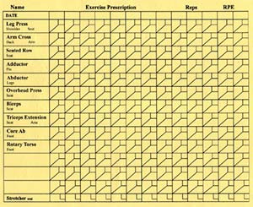
Leg Press
- Four-bar linkage movement arm enables maximum gluteus involvement.
- Seat back angle adjustment allows balancing range of motion and pressure on back.
- Heavily padded seat and shoulder pads for comfort and longevity.
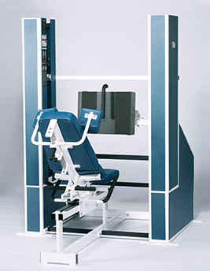

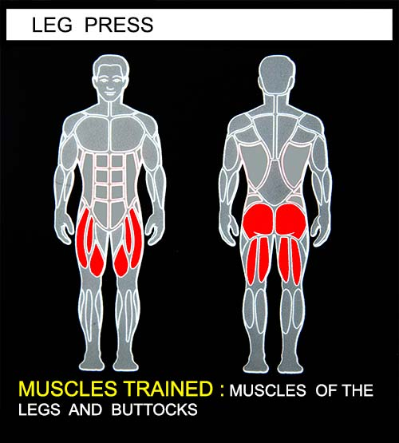
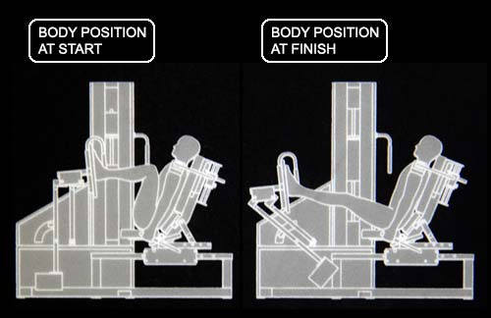

EXERCISE - Select a resistance with which you can perform 8 to 12 complete repetitions. Lightly grip the handlebars on either side of the seat to reduce upper body movement and maintain proper position. Push foot pads forward with heels as far as you can. Movement through full extension should take at least 4 seconds. Do not lock out your legs in the extended position. Pause for 1 second. Return to the starting position using a count of at least 4 seconds. Do not pause, immediately begin the next repetition. All movement should be controlled and deliberate. Avoid throwing or jerking the weight. Continue the exercise until you are unable to complete a repetition in good form.
COMMENTS - For best results, exercise should be performed throughout the greatest range of pain free movement.
The starting position can be varied by removing the selector pins from the weight stacks, moving the movement arms to the desired starting position and inserting the selector pins at the desired level of resistance.

