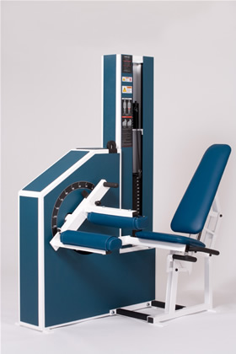Seated Leg Curl
- Movement arm design allows for easy access and proper alignment of the knee joint.
- Truncated seat allows support without impeding the hamstrings.
- Goniometer (angle detector) enables observation of proper range of motion.
EXERCISE -
- Pull up on handle beneath seat to set seat back depth for proper knee alignment (pivot point of knee in line with shield indication of axis of rotation).
- Set pin in top weight stack.
- Remove pin from bottom weight stack.
- Push handle of leg carriage to enable sliding legs into place as you sit in machine.
- While holding leg carriage, set bottom weight stack.
- Grasp handles alongside seat.
- Initiate the exercise by pulling feet downward smoothly.
- Pause in fully contracted position, reverse direction smoothly and repeat.
FOR ONE LEG OPERATION: - Pull leg carriage out of way and swing ledge upward and insert pin. Prop idle leg on ledge while exercising the other.
