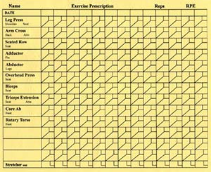
Yellow Exercise Machines

Arm Cross
- Adjustable back pad allows ideal shoulder alignment.
- Multi-position hand rest for comfort.
- Adjustable elbow pads for all sizes
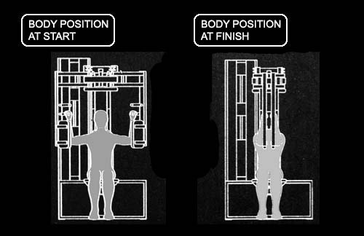
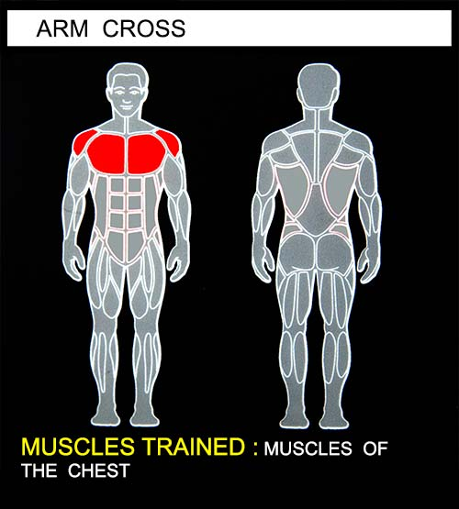
- Position body as shown in top diagram. The seat back should be adjusted to align the shoulders with the rotation axis of the machine.
- Select a resistance with which you can perform COM PLETE repetitions for 45 to 1 20 seconds, typically from 5 to 1 2 reps.
- Lift the weight smoothly and slowly by pressing the elbows toward each other. The lifting phase should take a MINIMUM of 4 seconds.
- Pause for 1 second while under load.
- Lower the weight smoothly and deliberately for a MINIMUM of 4 seconds.
- DO NOT PAUSE BETWEEN REPETITIONS.
- If you can complete a repetition in GOOD FORM, attempt another repetition.
- If you can perform COMPLETE repetitions for 45 to 120 seconds, increase the resistance for your next workout by approximately 5%.

