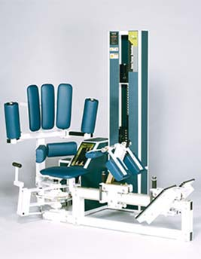Rotary torso (torso rotation)
- Unique padded restraint system neutralizes shoulder, arm and chest muscles while isolating waistline muscles.
- Separate system of padded restraints effectively locks the pelvis and prevents the hip and gluteus muscles from assisting in rotation of the torso.
- Increases strength and flexibility at the core of the body, making it a favorite among golf pros looking to increase club head speed.

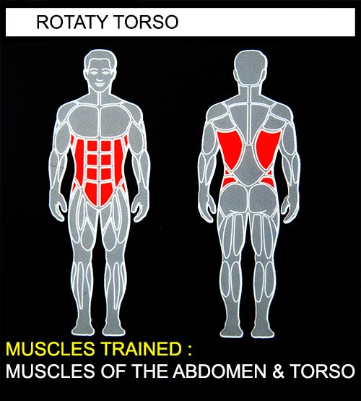
EXERCISE -
- Select a resistance with which you can perform 8 to 12 complete repetitions.
- Place one foot on the footboard, and sit back in the seat. Brace yourself with the other leg and pull the shin pad tightly against your shins. Once wedged tightly, place other foot on footboard and slide shin into place.
- Sit back against the pods, hooking both arms around rollers. Select the starting position by pushing the overhead release handle and rotating your torso as far aS possible to one side. Release the overhead handle and make sure the pin locks securely.
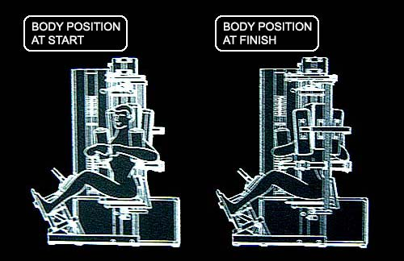
- Squeeze the cylinder pads against your chest.
- Rotate you torso as far as possible. Movement through full range should take at least 4 seconds.
- Pause for 1 second and return to the starting position using a count of at least 4 seconds.
- Do not pause, immediately begin next repetition.
- All movements should be controlled and deliberate. Avoid throwing or jerking the weight. Continue the exercise until you are unable to complete a repetition in good form.
- When finished exercising to one side, push up the release handle, rotate movement arm to the opposite side and repeat the exercise in the other direction.
COMMENTS - For best results exercise should be performed throughout greatest range of pain free movement.

