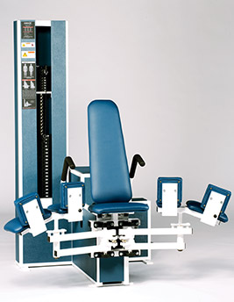Adductor (Hip Adductor / Inner Thigh)
- Back pad adjusts to three positions to target specific regions of the abductor muscles.
- Comfortable, contoured pads are adjustable and self-aligning for customized fit in machine.
- Smooth and low-friction cam follower design.
- Seat belt and handgrips maintain body position for isolated hip training.
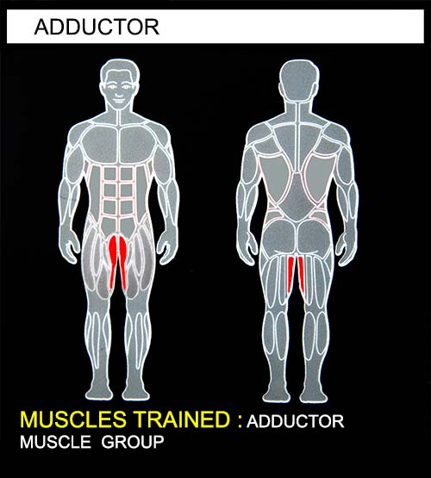
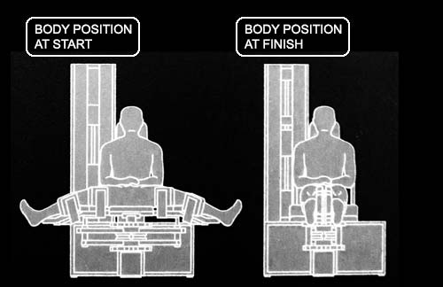EXERCISE - Select a resistance with which you can perform 8 to 12 complete repetitions. Movement arms can be released by pressing the handlebars on either side of the seat. This facilitates machine mounting and allows greater stretch in the starting position. Smoothly bring both legs together. Movement from full spread to closure should take at least 4 seconds. Pause for 1 second and return to the starting position using a count of at least 4 seconds. Do not pause, immediately begin the next repetition. All movement should be controlled and deliberate. Avoid throwing or jerking the weight. Continue the exercise until you are unable to complete a repetition in good form.
COMMENTS - For best results, exercise should be performed throughout the greatest range of pain free movement.

