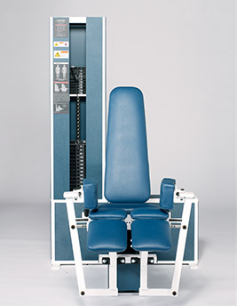Abductor (Hip Abductor/Outer Thigh)
- Self-adjusting pads on the legs reduce knee shear with primary force proximal to the knee.
- Adjustable back pad allows for proper positioning in machine.
- Smooth and low-friction cam follower design.
- Handles on both sides of the machine assist the user during entry and exit.
EXERCISE - Select a resistance with which you can perform 8 to 12 complete repetitions. Adjust resistance arm pads to fit snugly against outer thighs with legs together. Fasten seat belt and lightly grip the handlebars beside the seat to reduce upper body movement and maintain proper position. Smoothly spread both legs as wide as possible. Movement to full spread should take at least 4 seconds. Pause for 1 second and return to the starting position using a count of at least 4 seconds. Do not pause, immediately begin the next repetition. All movement should be controlled and deliberate. Avoid throwing or jerking the weight. Continue the exercise until you are unable to complete a repetition in good form. (Do not grip handlebars tightly with hands).
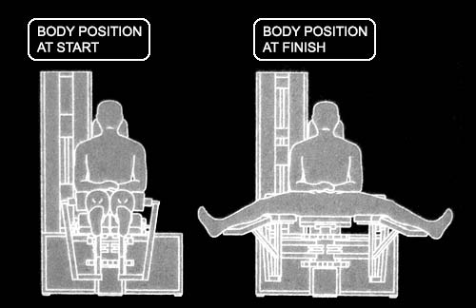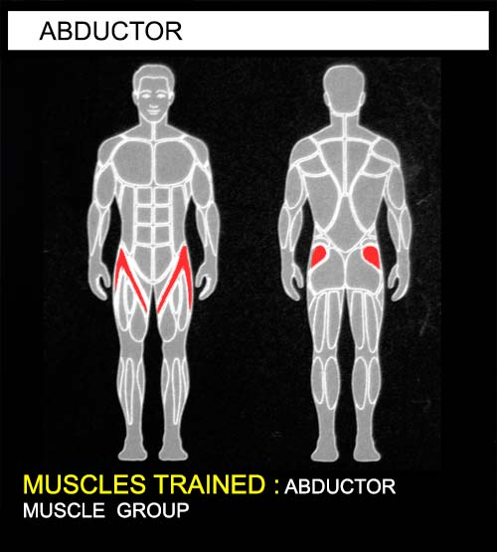COMMENTS - For best results, exercise should be performed throughout the greatest range of pain free movement.

